Министерство образования и молодежной политики Свердловской области



ГАПОУ СО «Екатеринбургский колледж транспортного строительства»

Отчёт по учебной практике

УП 01.01

Выполнила: Комаров Михаил Александрович

Группа: ПР-32

Преподаватель: Бушуева Е.В.

2023

# Тема: «Вводная практика»

**Приложение “** **Introductory_p02”:**

Данная программа осуществляет написание пользователем списка, просмотра списка и удаление элементов из списка.

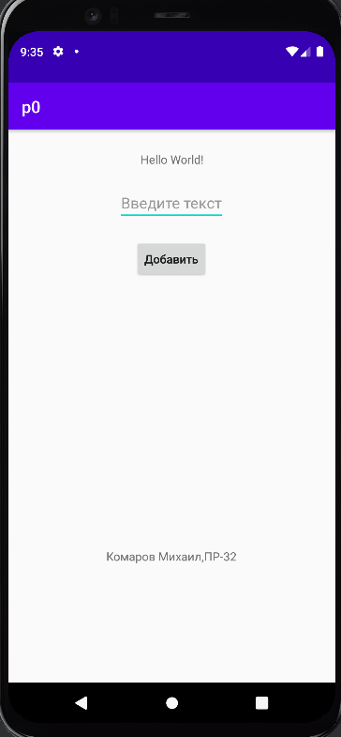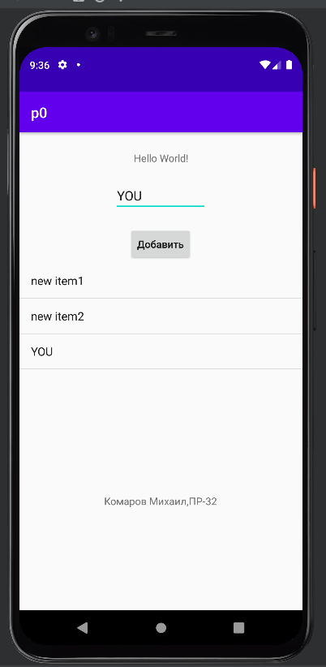

Структура проекта состоит из страниц(-ы):



Используемые инструменты:

* Среда разработки Android Studio для устройства Android.

Тестовые ситуации:

* Пустая строка.

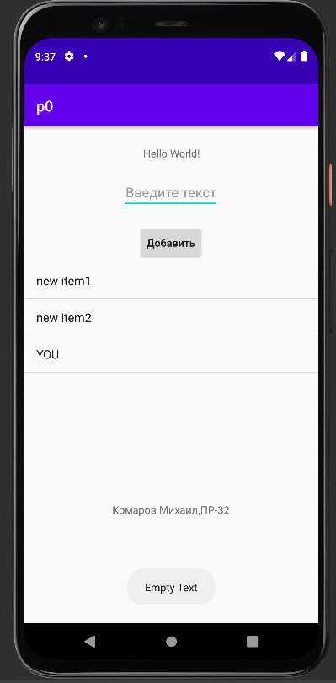

При нажатии на элемент в листе, элемент удалится:

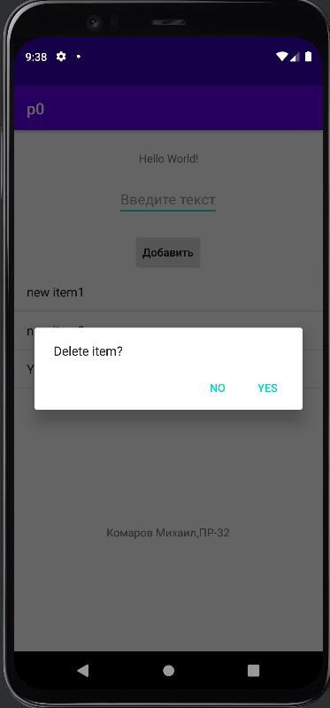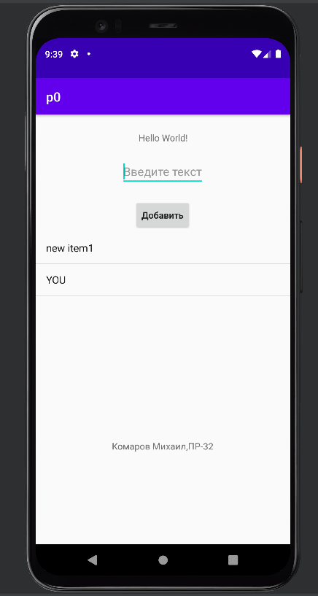

Листинг программы:

* activity_main.xml

<?xml version="1.0" encoding="utf-8"?>  
<android.support.constraint.ConstraintLayout xmlns:android="http://schemas.android.com/apk/res/android"  
 xmlns:app="http://schemas.android.com/apk/res-auto"  
 xmlns:tools="http://schemas.android.com/tools"  
 android:layout_width="match_parent"  
 android:layout_height="match_parent"  
 tools:context=".MainActivity">  
  
 <TextView  
 android:id="@+id/textView"  
 android:layout_width="wrap_content"  
 android:layout_height="wrap_content"  
 android:text="Hello World!"  
 app:layout_constraintBottom_toBottomOf="parent"  
 app:layout_constraintEnd_toEndOf="parent"  
 app:layout_constraintStart_toStartOf="parent"  
 app:layout_constraintTop_toTopOf="parent"  
 app:layout_constraintVertical_bias="0.04" />  
  
  
 <EditText  
 android:id="@+id/text_data"  
 android:layout_width="wrap_content"  
 android:layout_height="wrap_content"  
 android:hint="@string/Hint"  
 app:layout_constraintBottom_toBottomOf="parent"  
 app:layout_constraintEnd_toEndOf="parent"  
 app:layout_constraintHorizontal_bias="0.498"  
 app:layout_constraintStart_toStartOf="parent"  
 app:layout_constraintTop_toTopOf="parent"  
 app:layout_constraintVertical_bias="0.106" />  
  
 <Button  
 android:id="@+id/button"  
 android:layout_width="wrap_content"  
 android:layout_height="wrap_content"  
 android:text="@string/textButton"  
 android:textAllCaps="false"  
 app:layout_constraintBottom_toBottomOf="parent"  
 app:layout_constraintEnd_toEndOf="parent"  
 app:layout_constraintHorizontal_bias="0.498"  
 app:layout_constraintStart_toStartOf="parent"  
 app:layout_constraintTop_toTopOf="parent"  
 app:layout_constraintVertical_bias="0.213" />  
  
 <TextView  
 android:id="@+id/textView2"  
 android:layout_width="wrap_content"  
 android:layout_height="wrap_content"  
 android:text="@string/Fullname"  
 app:layout_constraintBottom_toBottomOf="parent"  
 app:layout_constraintEnd_toEndOf="parent"  
 app:layout_constraintHorizontal_bias="0.498"  
 app:layout_constraintStart_toStartOf="parent"  
 app:layout_constraintTop_toTopOf="parent"  
 app:layout_constraintVertical_bias="0.779" />  
  
 <ListView  
 android:id="@+id/list_data"  
 android:layout_width="wrap_content"  
 android:layout_height="300dp"  
 app:layout_constraintBottom_toBottomOf="parent"  
 app:layout_constraintEnd_toEndOf="parent"  
 app:layout_constraintStart_toStartOf="parent"  
 app:layout_constraintTop_toTopOf="parent" />  
  
</android.support.constraint.ConstraintLayout>

* activity_main.kt

package com.bignerdranch.android.p0  
  
import android.content.DialogInterface  
import android.support.v7.app.AppCompatActivity  
import android.os.Bundle  
import android.support.v7.app.AlertDialog  
import android.widget.*  
  
class MainActivity : AppCompatActivity() {  
 override fun onCreate(savedInstanceState: Bundle?) {  
 super.onCreate(savedInstanceState)  
 setContentView(R.layout.*activity_main*)  
 var label=findViewById<TextView>(R.id.*textView*)  
 var button=findViewById<Button>(R.id.*button*)  
 var textData: EditText = findViewById(R.id.*text_data*)  
 var listData: ListView =findViewById(R.id.*list_data*)  
 var label2=findViewById<TextView>(R.id.*textView2*)  
  
 var data= *arrayListOf*<String>()  
 var adapter= ArrayAdapter<String>(this,android.R.layout.*simple_list_item_1*, data);  
 listData.*adapter*=adapter  
  
 button.setOnClickListener**{** var text = textData.*text*.toString().*trim*()  
 if(!text.*isNullOrEmpty*())  
 {  
 data.add(text)  
 Toast.makeText(this, text, Toast.*LENGTH_SHORT*).show()  
 }  
 else  
 {  
 Toast.makeText(this, "Empty Text", Toast.*LENGTH_SHORT*).show()  
 }  
  
 **}** listData.setOnItemClickListener **{**_,_,position,_**->** var message= AlertDialog.Builder(this)  
 .setMessage("Delete item?")  
 .setPositiveButton("Yes",  
 DialogInterface.OnClickListener**{** dialog, which **->** data.removeAt(position)  
 adapter.notifyDataSetChanged()  
 Toast.makeText(this, "Item is delete", Toast.*LENGTH_SHORT*).show()  
 **}**)  
 .setNegativeButton("No",  
 DialogInterface.OnClickListener**{** dialog, which **->  
  
 }**)  
 .create()  
 .show()  
  
 **}** }  
}

# Тема: «Практическая работа №1, 2, 3 и 4»

**Приложение “p1-2”:**

Данная программа регистрирует пользователя (его логин, почта и пароль) и авторизует уже зарегистрированные пользователи.

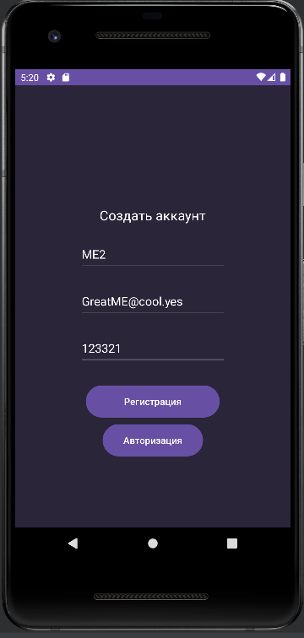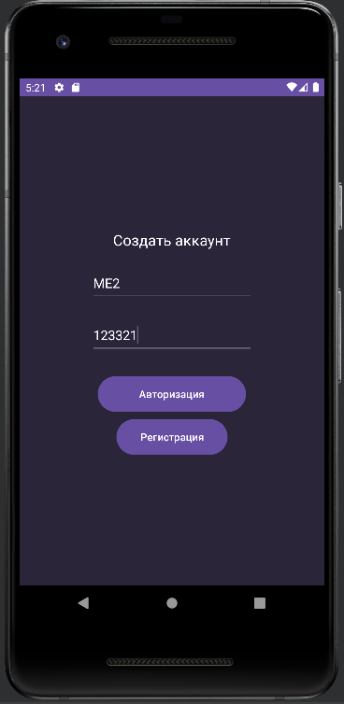

После авторизации или регистрации пользователю выдают список товаров.

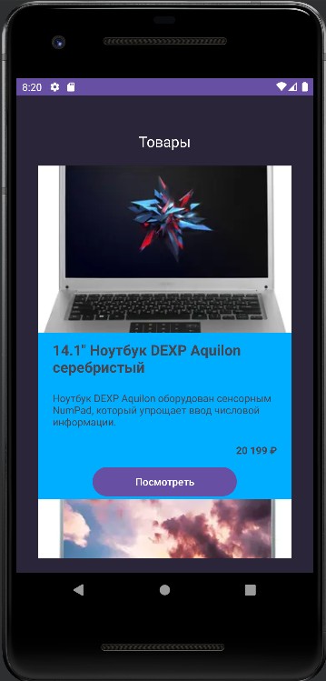

При нажатии кнопки “Посмотреть” выводится информация о товаре, кторый можно купить.

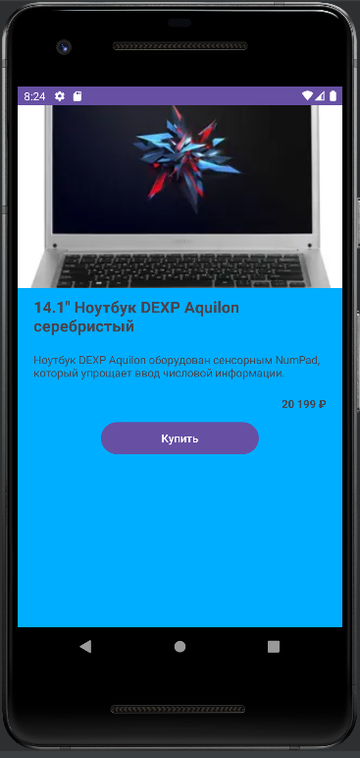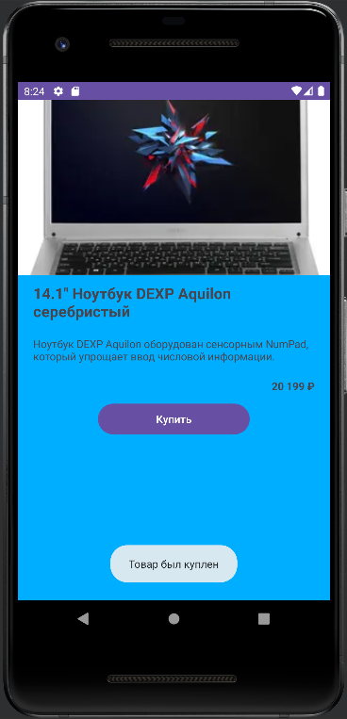

Структура проекта состоит из страниц(-ы):

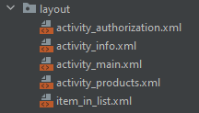

Используемые инструменты:

* Среда разработки Android Studio для устройства Android.

Тестовые ситуации:

* Пустые строки.

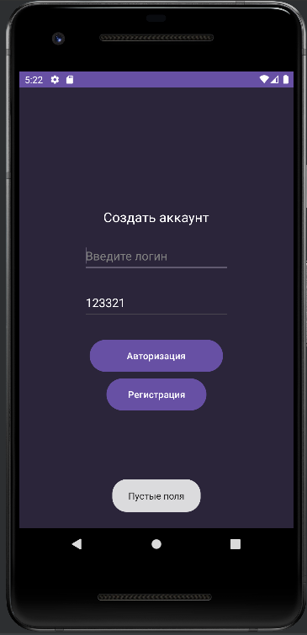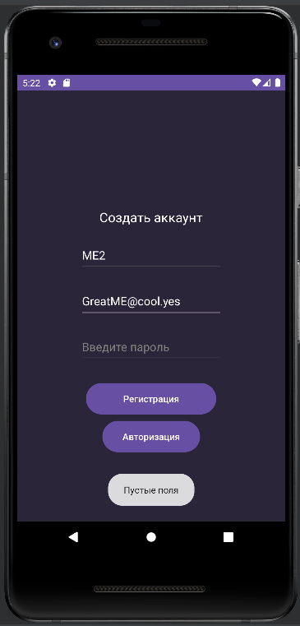

* Проверка маски почты.

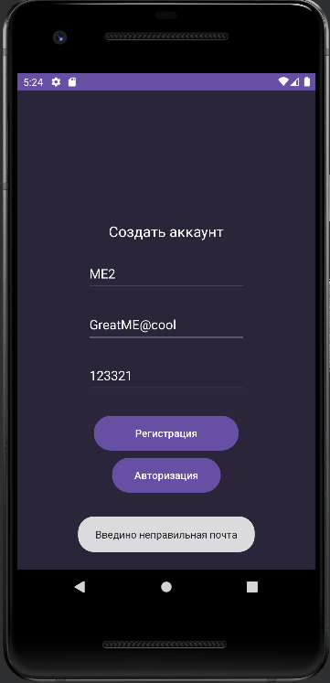

Листинг программ:

* activity_main.xml

<?xml version="1.0" encoding="utf-8"?>  
<LinearLayout xmlns:android="http://schemas.android.com/apk/res/android"  
 xmlns:app="http://schemas.android.com/apk/res-auto"  
 xmlns:tools="http://schemas.android.com/tools"  
 android:layout_width="match_parent"  
 android:layout_height="match_parent"  
 tools:context=".MainActivity"  
 android:orientation="vertical"  
 android:background="@color/Backround"  
 android:gravity="center_horizontal">  
  
 <TextView  
 android:layout_width="wrap_content"  
 android:layout_height="wrap_content"  
 android:layout_marginTop="180dp"  
 android:text="@string/text_registr"  
 android:textSize="20dp"  
 android:textColor="@color/white"  
 />  
 <EditText  
 android:layout_width="220dp"  
 android:layout_height="50dp"  
 android:layout_marginTop="20dp"  
 android:textColor="@color/white"  
 android:textColorHint="@color/grey"  
 android:id="@+id/user_login"  
 android:hint="@string/text_login"/>  
 <EditText  
 android:layout_width="220dp"  
 android:layout_height="50dp"  
 android:layout_marginTop="20dp"  
 android:textColor="@color/white"  
 android:textColorHint="@color/grey"  
 android:id="@+id/user_email"  
 android:hint="@string/text_email"/>  
 <EditText  
 android:layout_width="220dp"  
 android:layout_height="50dp"  
 android:layout_marginTop="20dp"  
 android:textColor="@color/white"  
 android:textColorHint="@color/grey"  
 android:id="@+id/user_password"  
 android:hint="@string/text_password"/>  
 <Button  
 android:layout_width="200dp"  
 android:layout_height="wrap_content"  
 android:layout_marginTop="30dp"  
 android:id="@+id/button_main"  
 android:textColor="@color/white"  
 android:textAllCaps="false"  
 android:background="@drawable/button"  
 android:text="@string/text_button_main"/>  
 <Button  
 android:layout_width="150dp"  
 android:layout_height="wrap_content"  
 android:layout_marginTop="10dp"  
 android:id="@+id/button_main_transition"  
 android:textColor="@color/white"  
 android:textAllCaps="false"  
 android:background="@drawable/button"  
 android:text="@string/text_button_authorization"/>  
  
  
</LinearLayout>

* activity_authorization.xml

<?xml version="1.0" encoding="utf-8"?>  
<LinearLayout xmlns:android="http://schemas.android.com/apk/res/android"  
 xmlns:app="http://schemas.android.com/apk/res-auto"  
 xmlns:tools="http://schemas.android.com/tools"  
 android:layout_width="match_parent"  
 android:layout_height="match_parent"  
 tools:context=".AuthorizationActivity"  
 android:orientation="vertical"  
 android:background="@color/Backround"  
 android:gravity="center_horizontal">  
  
 <TextView  
 android:layout_width="wrap_content"  
 android:layout_height="wrap_content"  
 android:layout_marginTop="180dp"  
 android:text="@string/text_registr"  
 android:textSize="20dp"  
 android:textColor="@color/white"  
 />  
 <EditText  
 android:layout_width="220dp"  
 android:layout_height="50dp"  
 android:layout_marginTop="20dp"  
 android:textColor="@color/white"  
 android:textColorHint="@color/grey"  
 android:id="@+id/user_login"  
 android:hint="@string/text_login"/>  
 <EditText  
 android:layout_width="220dp"  
 android:layout_height="50dp"  
 android:layout_marginTop="20dp"  
 android:textColor="@color/white"  
 android:textColorHint="@color/grey"  
 android:id="@+id/user_password"  
 android:hint="@string/text_password"/>  
 <Button  
 android:layout_width="200dp"  
 android:layout_height="wrap_content"  
 android:layout_marginTop="30dp"  
 android:id="@+id/button_authorization"  
 android:textColor="@color/white"  
 android:textAllCaps="false"  
 android:background="@drawable/button"  
 android:text="@string/text_button_authorization"/>  
 <Button  
 android:layout_width="150dp"  
 android:layout_height="wrap_content"  
 android:layout_marginTop="10dp"  
 android:id="@+id/button_authorization_transition"  
 android:textColor="@color/white"  
 android:textAllCaps="false"  
 android:background="@drawable/button"  
 android:text="@string/text_button_main"/>  
  
</LinearLayout>

* activity_info.xml

<?xml version="1.0" encoding="utf-8"?>  
<LinearLayout xmlns:android="http://schemas.android.com/apk/res/android"  
 xmlns:app="http://schemas.android.com/apk/res-auto"  
 xmlns:tools="http://schemas.android.com/tools"  
 android:layout_width="match_parent"  
 android:layout_height="match_parent"  
 tools:context=".InfoActivity"  
 android:orientation="vertical"  
 android:background="@color/blue_2">  
 <ImageView  
 android:layout_width="match_parent"  
 android:layout_height="wrap_content"  
 android:scaleType="centerCrop"  
 android:id="@+id/itemImage"/>  
 <TextView  
 android:layout_width="match_parent"  
 android:layout_height="wrap_content"  
 android:text="TextView"  
 android:textSize="20dp"  
 android:layout_marginVertical="10dp"  
 android:layout_marginLeft="20dp"  
 android:id="@+id/itemTitle"  
 android:textStyle="bold"  
 />  
 <TextView  
 android:layout_width="match_parent"  
 android:layout_height="wrap_content"  
 android:text="TextView"  
 android:layout_marginVertical="10dp"  
 android:layout_marginLeft="20dp"  
 android:id="@+id/itemDecs"/>  
 <TextView  
 android:layout_width="match_parent"  
 android:layout_height="wrap_content"  
 android:gravity="right"  
 android:text="TextView"  
 android:layout_marginVertical="10dp"  
 android:layout_marginRight="20dp"  
 android:id="@+id/itemPrice"  
 android:textStyle="bold"/>  
 <Button  
 android:layout_width="200dp"  
 android:layout_height="wrap_content"  
 android:layout_gravity="center"  
 android:id="@+id/itemBue"  
 android:text="Купить"/>  
  
</LinearLayout>

* activity_products.xml

<?xml version="1.0" encoding="utf-8"?>  
<LinearLayout xmlns:android="http://schemas.android.com/apk/res/android"  
 xmlns:app="http://schemas.android.com/apk/res-auto"  
 xmlns:tools="http://schemas.android.com/tools"  
 android:layout_width="match_parent"  
 android:layout_height="match_parent"  
 tools:context=".ProductsActivity"  
 android:orientation="vertical"  
 android:background="@color/Backround"  
 android:gravity="center_horizontal">  
  
 <TextView  
 android:layout_width="wrap_content"  
 android:layout_height="wrap_content"  
 android:text="@string/text_products"  
 android:layout_marginTop="50dp"  
 android:textSize="20dp"  
 android:textColor="@color/white"/>  
  
 <androidx.recyclerview.widget.RecyclerView  
 android:layout_width="match_parent"  
 android:layout_height="match_parent"  
 android:id="@+id/RecyclerView_Products"  
 android:layout_marginHorizontal="30dp"  
 android:layout_marginVertical="20dp"  
 />  
  
</LinearLayout>

* item_in_list.xml

<?xml version="1.0" encoding="utf-8"?>  
<LinearLayout xmlns:android="http://schemas.android.com/apk/res/android"  
 android:orientation="vertical"  
 android:layout_width="match_parent"  
 android:layout_height="wrap_content"  
 android:background="@color/blue_2">  
 <ImageView  
 android:layout_width="match_parent"  
 android:layout_height="wrap_content"  
 android:scaleType="centerCrop"  
 android:id="@+id/item_list_image"/>  
 <TextView  
 android:layout_width="match_parent"  
 android:layout_height="wrap_content"  
 android:text="TextView"  
 android:textSize="20dp"  
 android:layout_marginVertical="10dp"  
 android:layout_marginLeft="20dp"  
 android:id="@+id/item_list_title"  
 android:textStyle="bold"  
 />  
 <TextView  
 android:layout_width="match_parent"  
 android:layout_height="wrap_content"  
 android:text="TextView"  
 android:layout_marginVertical="10dp"  
 android:layout_marginLeft="20dp"  
 android:id="@+id/item_list_decs"/>  
 <TextView  
 android:layout_width="match_parent"  
 android:layout_height="wrap_content"  
 android:gravity="right"  
 android:text="TextView"  
 android:layout_marginVertical="10dp"  
 android:layout_marginRight="20dp"  
 android:id="@+id/item_list_price"  
 android:textStyle="bold"/>  
 <Button  
 android:layout_width="200dp"  
 android:layout_height="wrap_content"  
 android:layout_gravity="center"  
 android:id="@+id/item_list_info"  
 android:text="Посмотреть"/>  
  
</LinearLayout>

# Тема: «Практическая работа №5»

**Приложение “p2”:**

Данная программа при нажатии на кнопку “Поздороваться” программа здоровается с пользователем.

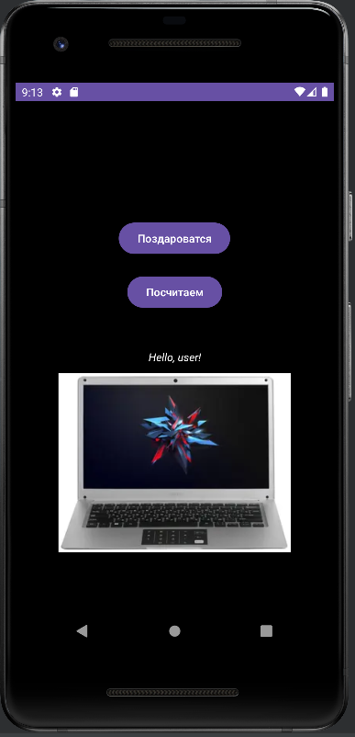

При нажатии на кнопку “Посчитаем ” и картинку программа считает количества кликов и каждого элемента.

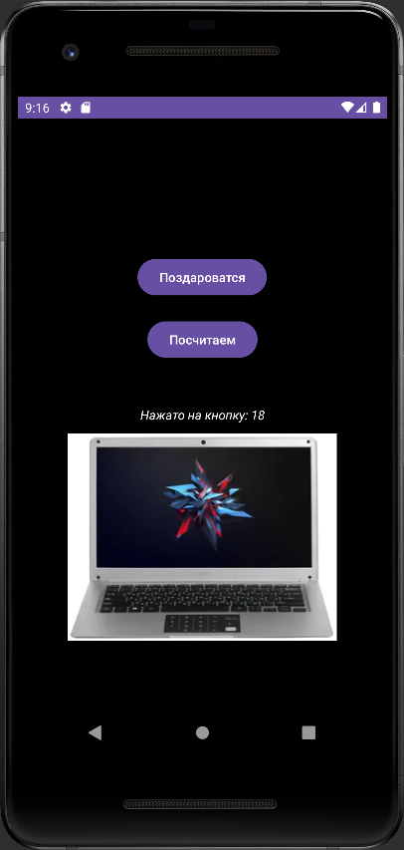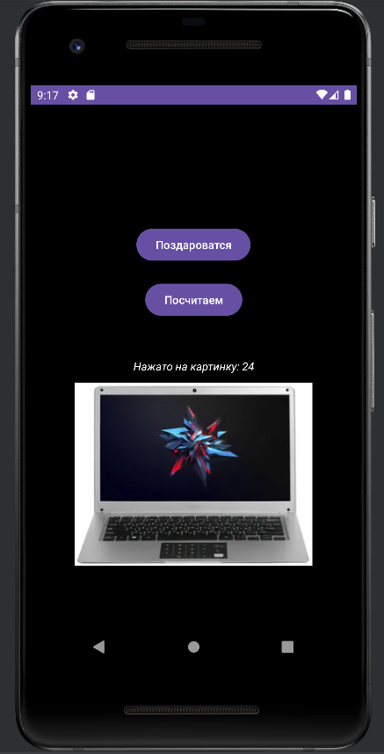

Структура проекта состоит из страниц(-ы):



Используемые инструменты:

* Среда разработки Android Studio для устройства Android.

Тестовые ситуации: Отсутствуют.

Листинг программы:

* activity_main.xml

<?xml version="1.0" encoding="utf-8"?>  
<androidx.constraintlayout.widget.ConstraintLayout xmlns:android="http://schemas.android.com/apk/res/android"  
 xmlns:app="http://schemas.android.com/apk/res-auto"  
 xmlns:tools="http://schemas.android.com/tools"  
 android:layout_width="match_parent"  
 android:layout_height="match_parent"  
 tools:context=".MainActivity"  
 android:background="@color/black">  
  
 <TextView  
 android:id="@+id/TextView"  
 android:layout_width="wrap_content"  
 android:layout_height="wrap_content"  
 android:text="Hello World!"  
 app:layout_constraintBottom_toBottomOf="parent"  
 app:layout_constraintEnd_toEndOf="parent"  
 app:layout_constraintStart_toStartOf="parent"  
 app:layout_constraintTop_toTopOf="parent"  
 android:textStyle="italic"  
 android:textColor="@color/white"/>  
  
 <Button  
 android:id="@+id/hello_button"  
 android:layout_width="wrap_content"  
 android:layout_height="wrap_content"  
 android:text="@string/text_hello_button"  
 app:layout_constraintBottom_toBottomOf="parent"  
 app:layout_constraintEnd_toEndOf="parent"  
 app:layout_constraintHorizontal_bias="0.498"  
 app:layout_constraintStart_toStartOf="parent"  
 app:layout_constraintTop_toTopOf="parent"  
 app:layout_constraintVertical_bias="0.25" />  
  
 <Button  
 android:id="@+id/click_button"  
 android:layout_width="wrap_content"  
 android:layout_height="wrap_content"  
 android:text="@string/text_click_button"  
 app:layout_constraintBottom_toBottomOf="parent"  
 app:layout_constraintEnd_toEndOf="parent"  
 app:layout_constraintStart_toStartOf="parent"  
 app:layout_constraintTop_toTopOf="parent"  
 app:layout_constraintVertical_bias="0.363" />  
  
 <ImageView  
 android:id="@+id/click_imageView"  
 android:layout_width="wrap_content"  
 android:layout_height="wrap_content"  
 android:src="@drawable/product1"  
 android:scaleType="centerCrop"  
 app:layout_constraintBottom_toBottomOf="parent"  
 app:layout_constraintEnd_toEndOf="parent"  
 app:layout_constraintHorizontal_bias="0.495"  
 app:layout_constraintStart_toStartOf="parent"  
 app:layout_constraintTop_toTopOf="parent"  
 app:layout_constraintVertical_bias="0.818" />  
  
</androidx.constraintlayout.widget.ConstraintLayout>

# Тема: «Практическая работа №6»

**Приложение “p3”:**

Приложение имеет иконку:



Приложение позволяет в зависимости от нажатой кнопки менять цвет фона.

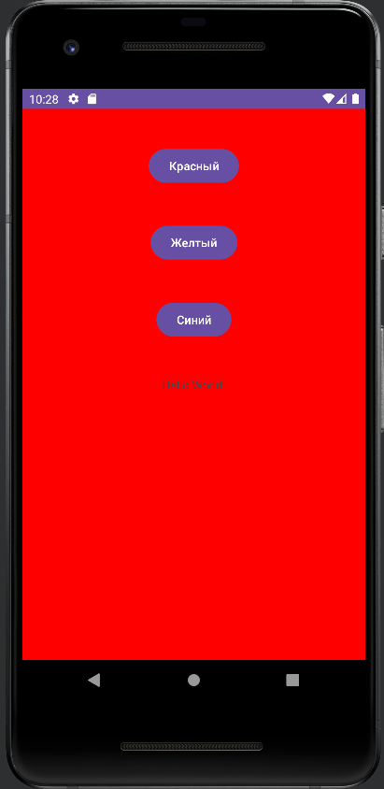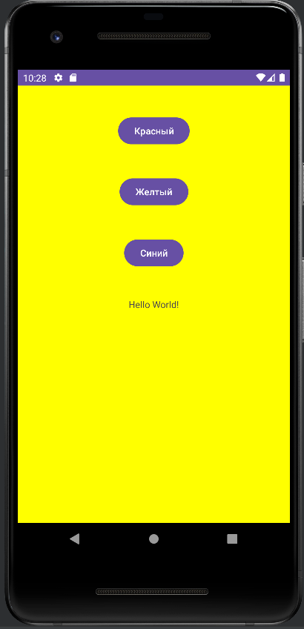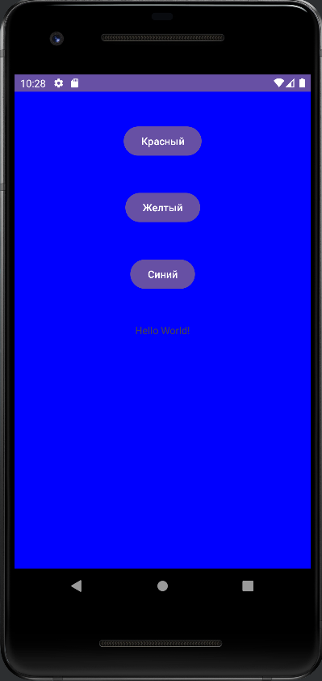

Структура проекта состоит из страниц(-ы):



Используемые инструменты:

* Среда разработки Android Studio для устройства Android.

Тестовые ситуации: Отсутствуют.

Листинг программы:

* activity_main.xml

<?xml version="1.0" encoding="utf-8"?>  
<androidx.constraintlayout.widget.ConstraintLayout xmlns:android="http://schemas.android.com/apk/res/android"  
 xmlns:app="http://schemas.android.com/apk/res-auto"  
 xmlns:tools="http://schemas.android.com/tools"  
 android:layout_width="match_parent"  
 android:layout_height="match_parent"  
 tools:context=".MainActivity"  
 android:id="@+id/root_layout"  
 android:background="@color/red">  
  
 <TextView  
 android:id="@+id/textView"  
 android:layout_width="wrap_content"  
 android:layout_height="wrap_content"  
 android:text="Hello World!"  
 app:layout_constraintBottom_toBottomOf="parent"  
 app:layout_constraintEnd_toEndOf="parent"  
 app:layout_constraintStart_toStartOf="parent"  
 app:layout_constraintTop_toTopOf="parent" />  
  
 <Button  
 android:id="@+id/button_red"  
 android:layout_width="wrap_content"  
 android:layout_height="wrap_content"  
 android:gravity="center_horizontal|center_vertical"  
 android:orientation="horizontal"  
 android:text="@string/text_button_red"  
 app:layout_constraintBottom_toTopOf="@+id/button_yellow"  
 app:layout_constraintEnd_toEndOf="parent"  
 app:layout_constraintStart_toStartOf="parent"  
 app:layout_constraintTop_toTopOf="parent" />  
  
 <Button  
 android:id="@+id/button_yellow"  
 android:layout_width="wrap_content"  
 android:layout_height="wrap_content"  
 android:gravity="center_horizontal|center_vertical"  
 android:orientation="horizontal"  
 android:text="@string/text_button_yellow"  
 app:layout_constraintBottom_toTopOf="@+id/button_blue"  
 app:layout_constraintEnd_toEndOf="parent"  
 app:layout_constraintStart_toStartOf="parent"  
 app:layout_constraintTop_toBottomOf="@+id/button_red" />  
  
 <Button  
 android:id="@+id/button_blue"  
 android:layout_width="wrap_content"  
 android:layout_height="wrap_content"  
 android:gravity="center_horizontal|center_vertical"  
 android:orientation="horizontal"  
 android:text="@string/text_button_blue"  
 app:layout_constraintBottom_toTopOf="@+id/textView"  
 app:layout_constraintEnd_toEndOf="parent"  
 app:layout_constraintStart_toStartOf="parent"  
 app:layout_constraintTop_toBottomOf="@+id/button_yellow" />  
  
</androidx.constraintlayout.widget.ConstraintLayout>

**Приложение “p4”:**

Приложение имеет иконку:



Приложение позволяет менять стиль и размер текста.

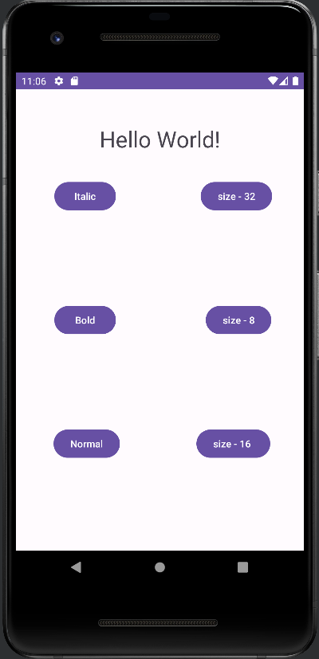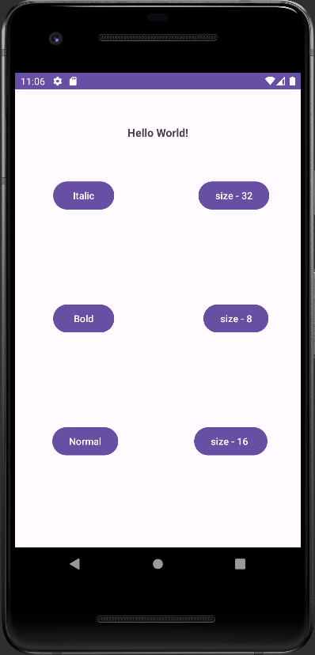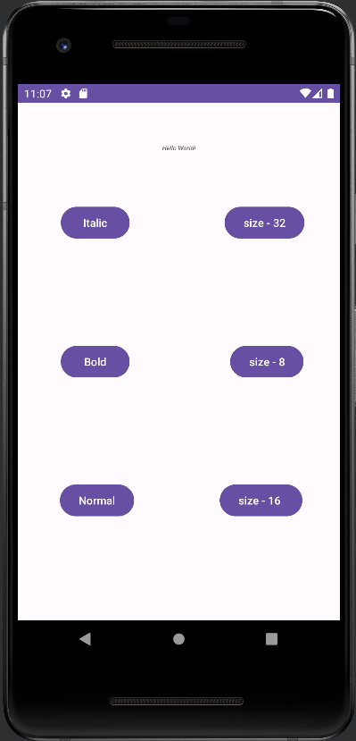

Структура проекта состоит из страниц(-ы):



Используемые инструменты:

* Среда разработки Android Studio для устройства Android.

Тестовые ситуации: Отсутствуют.

Листинг программы:

* activity_main.xml

<?xml version="1.0" encoding="utf-8"?>  
<androidx.constraintlayout.widget.ConstraintLayout xmlns:android="http://schemas.android.com/apk/res/android"  
 xmlns:app="http://schemas.android.com/apk/res-auto"  
 xmlns:tools="http://schemas.android.com/tools"  
 android:layout_width="match_parent"  
 android:layout_height="match_parent"  
 tools:context=".MainActivity"  
 tools:layout_editor_absoluteX="234dp"  
 tools:layout_editor_absoluteY="-2dp">  
  
 <TextView  
 android:layout_width="wrap_content"  
 android:layout_height="wrap_content"  
 android:id="@+id/TextView"  
 android:text="Hello World!"  
 android:textStyle="normal"  
 app:layout_constraintBottom_toBottomOf="parent"  
 app:layout_constraintEnd_toEndOf="parent"  
 app:layout_constraintStart_toStartOf="parent"  
 app:layout_constraintTop_toTopOf="parent"  
 app:layout_constraintVertical_bias="0.08" />  
  
 <Button  
 android:id="@+id/button_size_32"  
 android:layout_width="wrap_content"  
 android:layout_height="wrap_content"  
 android:text="size - 32"  
 app:layout_constraintBottom_toTopOf="@+id/button_size_8"  
 app:layout_constraintEnd_toEndOf="parent"  
 app:layout_constraintHorizontal_bias="0.854"  
 app:layout_constraintStart_toStartOf="parent"  
 app:layout_constraintTop_toTopOf="parent" />  
  
 <Button  
 android:id="@+id/button_size_16"  
 android:layout_width="wrap_content"  
 android:layout_height="wrap_content"  
 android:text="size - 8 "  
 app:layout_constraintBottom_toBottomOf="parent"  
 app:layout_constraintEnd_toEndOf="parent"  
 app:layout_constraintHorizontal_bias="0.843"  
 app:layout_constraintStart_toStartOf="parent"  
 app:layout_constraintTop_toBottomOf="@+id/button_size_8" />  
  
 <Button  
 android:id="@+id/button_size_8"  
 android:layout_width="wrap_content"  
 android:layout_height="wrap_content"  
 android:text="size - 16"  
 app:layout_constraintBottom_toTopOf="@+id/button_size_16"  
 app:layout_constraintEnd_toEndOf="parent"  
 app:layout_constraintHorizontal_bias="0.854"  
 app:layout_constraintStart_toStartOf="parent"  
 app:layout_constraintTop_toBottomOf="@+id/button_size_32" />  
  
 <Button  
 android:id="@+id/button_italic"  
 android:layout_width="wrap_content"  
 android:layout_height="wrap_content"  
 android:text="Italic"  
 app:layout_constraintBottom_toTopOf="@+id/button_bold"  
 app:layout_constraintEnd_toEndOf="parent"  
 app:layout_constraintHorizontal_bias="0.17"  
 app:layout_constraintStart_toStartOf="parent"  
 app:layout_constraintTop_toTopOf="parent" />  
  
 <Button  
 android:id="@+id/button_bold"  
 android:layout_width="wrap_content"  
 android:layout_height="wrap_content"  
 android:text="Bold"  
 app:layout_constraintBottom_toTopOf="@+id/button_normal"  
 app:layout_constraintEnd_toEndOf="parent"  
 app:layout_constraintHorizontal_bias="0.17"  
 app:layout_constraintStart_toStartOf="parent"  
 app:layout_constraintTop_toBottomOf="@+id/button_italic" />  
  
 <Button  
 android:id="@+id/button_normal"  
 android:layout_width="wrap_content"  
 android:layout_height="wrap_content"  
 android:text="Normal"  
 app:layout_constraintBottom_toBottomOf="parent"  
 app:layout_constraintEnd_toEndOf="parent"  
 app:layout_constraintHorizontal_bias="0.17"  
 app:layout_constraintStart_toStartOf="parent"  
 app:layout_constraintTop_toBottomOf="@+id/button_bold" />  
  
</androidx.constraintlayout.widget.ConstraintLayout>

# Тема: «Практическая работа №7, 8»

**Приложение “p5”:**

# Тема: «Практическая работа №9»

**Приложение “p6”:**

Положение представляет из себя один экран с анимированными объектами.

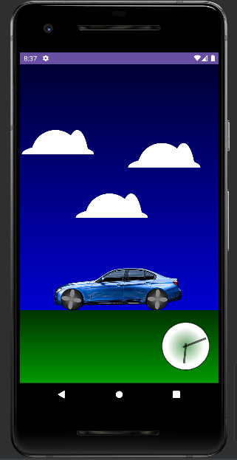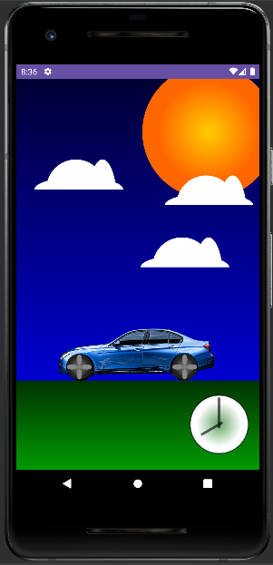

Структура проекта состоит из страниц(-ы):



Используемые инструменты:

* Среда разработки Android Studio для устройства Android.

Тестовые ситуации: Отсутствуют.

Листинг программы:

* activity_main.xml

<?xml version="1.0" encoding="utf-8"?>  
<androidx.constraintlayout.widget.ConstraintLayout xmlns:android="http://schemas.android.com/apk/res/android"  
 xmlns:app="http://schemas.android.com/apk/res-auto"  
 xmlns:tools="http://schemas.android.com/tools"  
 android:layout_width="match_parent"  
 android:layout_height="match_parent"  
 tools:context=".MainActivity">  
  
 <ImageView  
 android:id="@+id/sky"  
 android:layout_width="0dp"  
 android:layout_height="0dp"  
 android:contentDescription="@string/sky"  
 android:src="@drawable/sky"  
 app:layout_constraintBottom_toBottomOf="parent"  
 app:layout_constraintEnd_toEndOf="parent"  
 app:layout_constraintHorizontal_bias="0.0"  
 app:layout_constraintStart_toStartOf="parent"  
 app:layout_constraintTop_toTopOf="parent"  
 app:layout_constraintVertical_bias="0.0" />  
  
 <ImageView  
 android:id="@+id/sun"  
 android:layout_width="wrap_content"  
 android:layout_height="wrap_content"  
 android:layout_centerHorizontal="true"  
 android:contentDescription="@string/sun"  
 android:scaleType="fitCenter"  
 android:src="@drawable/sun"  
 app:layout_constraintEnd_toEndOf="parent"  
 app:layout_constraintStart_toStartOf="parent"  
 app:layout_constraintTop_toTopOf="parent" />  
  
 <ImageView  
 android:id="@+id/grass"  
 android:layout_width="0dp"  
 android:layout_height="150dp"  
 android:contentDescription="@string/grass"  
 android:src="@drawable/grass"  
 app:layout_constraintBottom_toBottomOf="parent"  
 app:layout_constraintEnd_toEndOf="parent"  
 app:layout_constraintStart_toStartOf="parent" />  
 <ImageView  
 android:id="@+id/clock"  
 android:layout_width="wrap_content"  
 android:layout_height="wrap_content"  
 android:layout_alignParentRight="true"  
 android:layout_alignParentBottom="true"  
 android:layout_marginEnd="8dp"  
 android:layout_marginRight="8dp"  
 android:layout_marginBottom="16dp"  
 android:contentDescription="@string/clock"  
 android:padding="10dp"  
 android:src="@drawable/clock"  
 app:layout_constraintBottom_toBottomOf="parent"  
 app:layout_constraintEnd_toEndOf="parent"/>  
  
 <ImageView  
 android:id="@+id/hour_hand"  
 android:layout_width="wrap_content"  
 android:layout_height="wrap_content"  
 android:layout_alignParentRight="true"  
 android:layout_alignParentBottom="true"  
 android:layout_marginEnd="8dp"  
 android:contentDescription="@string/clock"  
 android:padding="10dp"  
 android:src="@drawable/hour_hand"  
 app:layout_constraintEnd_toEndOf="@+id/sky"  
 app:layout_constraintTop_toTopOf="@+id/clock" />  
  
 <ImageView  
 android:id="@+id/imageView"  
 android:layout_width="300dp"  
 android:layout_height="wrap_content"  
 android:layout_marginBottom="36dp"  
 android:src="@drawable/car"  
 app:layout_constraintBottom_toBottomOf="parent"  
 app:layout_constraintEnd_toEndOf="parent"  
 app:layout_constraintHorizontal_bias="0.495"  
 app:layout_constraintStart_toStartOf="parent" />  
  
 <ImageView  
 android:id="@+id/wheel1"  
 android:layout_width="45dp"  
 android:layout_height="45dp"  
 android:layout_marginStart="84dp"  
 android:layout_marginTop="176dp"  
 android:src="@drawable/wheel"  
 app:layout_constraintBottom_toBottomOf="parent"  
 app:layout_constraintStart_toStartOf="parent"  
 app:layout_constraintTop_toTopOf="@+id/imageView"  
 app:layout_constraintVertical_bias="0.006" />  
  
 <ImageView  
 android:id="@+id/wheel2"  
 android:layout_width="45dp"  
 android:layout_height="45dp"  
 android:layout_marginTop="176dp"  
 android:layout_marginEnd="104dp"  
 android:src="@drawable/wheel"  
 app:layout_constraintBottom_toBottomOf="parent"  
 app:layout_constraintEnd_toEndOf="parent"  
 app:layout_constraintTop_toTopOf="@+id/imageView"  
 app:layout_constraintVertical_bias="0.006" />  
  
 <ImageView  
 android:layout_width="150dp"  
 android:layout_height="wrap_content"  
 android:id="@+id/could1"  
 android:src="@drawable/cloud"  
 app:layout_constraintBottom_toBottomOf="parent"  
 app:layout_constraintEnd_toEndOf="parent"  
 app:layout_constraintHorizontal_bias="0.003"  
 app:layout_constraintStart_toStartOf="parent"  
 app:layout_constraintTop_toTopOf="parent"  
 app:layout_constraintVertical_bias="0.072" />  
  
 <ImageView  
 android:layout_width="150dp"  
 android:layout_height="wrap_content"  
 android:id="@+id/could2"  
 android:src="@drawable/cloud"  
 app:layout_constraintBottom_toBottomOf="parent"  
 app:layout_constraintEnd_toEndOf="parent"  
 app:layout_constraintHorizontal_bias="0.846"  
 app:layout_constraintStart_toStartOf="parent"  
 app:layout_constraintTop_toTopOf="parent"  
 app:layout_constraintVertical_bias="0.125" />  
  
 <ImageView  
 android:layout_width="150dp"  
 android:layout_height="wrap_content"  
 android:id="@+id/could3"  
 android:src="@drawable/cloud"  
 app:layout_constraintBottom_toBottomOf="parent"  
 app:layout_constraintEnd_toEndOf="parent"  
 app:layout_constraintHorizontal_bias="0.345"  
 app:layout_constraintStart_toStartOf="parent"  
 app:layout_constraintTop_toTopOf="parent"  
 app:layout_constraintVertical_bias="0.33" />  
  
</androidx.constraintlayout.widget.ConstraintLayout>

# **Тема: «Практическая работа №10, 11»**

**Приложение “p7”:**

Положение представляет из себя множество экранов. Привходе пользователя в встречает экран загрузки.

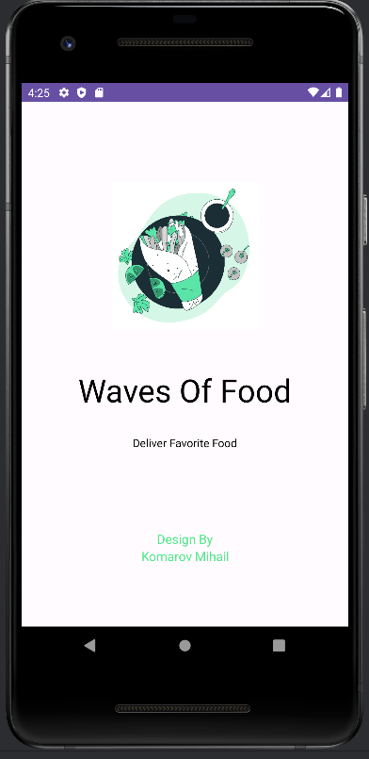

После которого переходим на следующий экран.

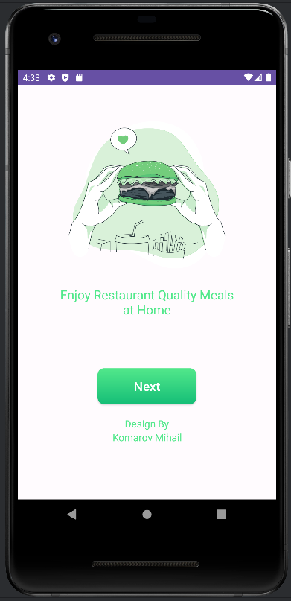

При нажатии на кнопку “Next” приложение переносит на экран вход в свою учетную запись.

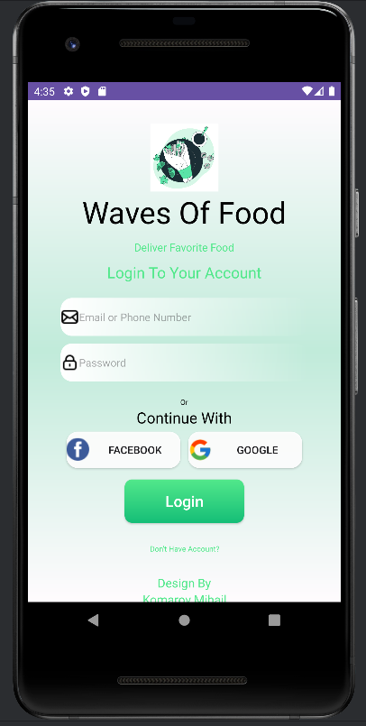

При нажатии на надпись “Don”t Have Account” приложение переносит на экран Создание Аккаунта.

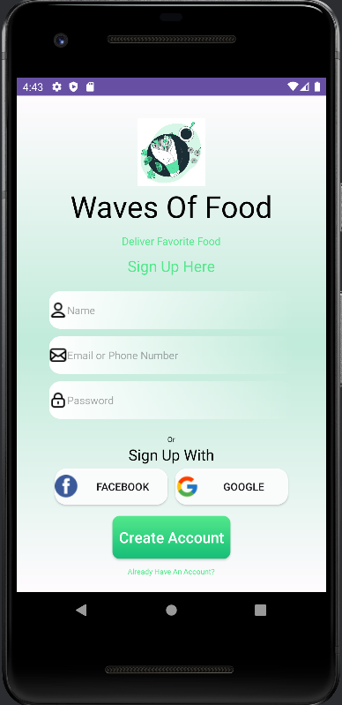

При нажатии на “Create Account” приложение переносит на экран Выбора своей локации. При выборе выводится сообщение об подтверждении пользователем выборной локации.

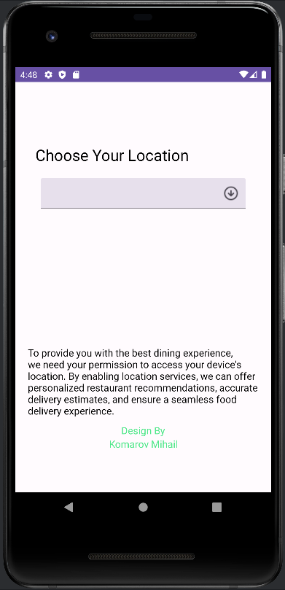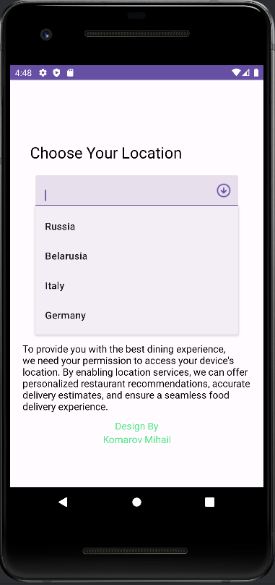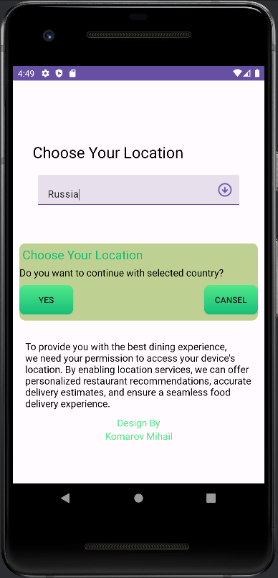

При подтверждение пользователя переносит на следующий экран.

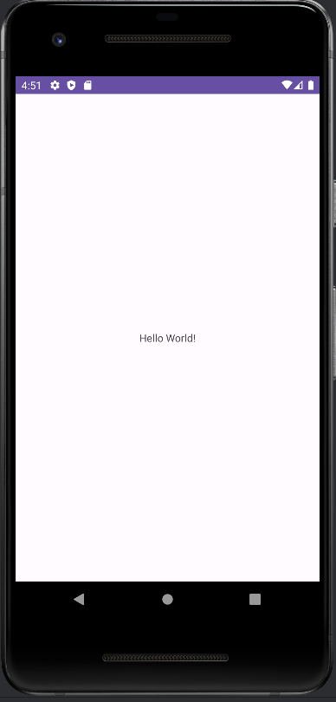

Структура проекта состоит из страниц(-ы):

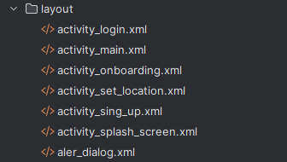

Используемые инструменты:

* Среда разработки Android Studio для устройства Android.

Тестовые ситуации: Отсутствуют.

Листинг программы:

* activity_main.xml

<?xml version="1.0" encoding="utf-8"?>  
<androidx.constraintlayout.widget.ConstraintLayout xmlns:android="http://schemas.android.com/apk/res/android"  
 xmlns:app="http://schemas.android.com/apk/res-auto"  
 xmlns:tools="http://schemas.android.com/tools"  
 android:layout_width="match_parent"  
 android:layout_height="match_parent"  
 tools:context=".MainActivity">  
  
 <TextView  
 android:layout_width="wrap_content"  
 android:layout_height="wrap_content"  
 android:text="Hello World!"  
 app:layout_constraintBottom_toBottomOf="parent"  
 app:layout_constraintEnd_toEndOf="parent"  
 app:layout_constraintStart_toStartOf="parent"  
 app:layout_constraintTop_toTopOf="parent" />  
  
</androidx.constraintlayout.widget.ConstraintLayout>

* activity_login.xml

<?xml version="1.0" encoding="utf-8"?>  
<LinearLayout xmlns:android="http://schemas.android.com/apk/res/android"  
 xmlns:app="http://schemas.android.com/apk/res-auto"  
 xmlns:tools="http://schemas.android.com/tools"  
 android:layout_width="match_parent"  
 android:layout_height="match_parent"  
 tools:context=".Login"  
 android:gravity="center_horizontal"  
 android:orientation="vertical"  
 android:background="@drawable/spe_background">  
 <ImageView  
 android:layout_width="90dp"  
 android:layout_height="90dp"  
 android:layout_marginTop="30dp"  
 android:src="@drawable/logo"/>  
 <TextView  
 android:layout_width="wrap_content"  
 android:layout_height="wrap_content"  
 android:text="Waves Of Food"  
 android:textSize="40dp"  
 android:layout_marginTop="0dp"  
 android:textColor="@color/black"  
 />  
  
 <TextView  
 android:layout_width="wrap_content"  
 android:layout_height="wrap_content"  
 android:layout_marginTop="10dp"  
 android:text="Deliver Favorite Food"  
 android:textColor="@color/startGreenColor"  
 android:textSize="14dp"  
 tools:ignore="TextSizeCheck" />  
 <TextView  
 android:layout_width="wrap_content"  
 android:layout_height="wrap_content"  
 android:text="Login To Your Account"  
 android:textSize="20dp"  
 android:layout_marginTop="10dp"  
 android:textColor="@color/startGreenColor"/>  
  
 <EditText  
 android:layout_width="325dp"  
 android:layout_height="50dp"  
 android:layout_marginTop="20dp"  
 android:background="@drawable/edittxt"  
 android:drawableStart="@drawable/ic_mail"  
 android:hint="Email or Phone Number"  
 android:textSize="14dp"  
 tools:ignore="TextSizeCheck" />  
  
 <EditText  
 android:layout_width="325dp"  
 android:layout_height="50dp"  
 android:layout_marginTop="10dp"  
 android:background="@drawable/edittxt"  
 android:drawableStart="@drawable/ic_lock"  
 android:hint="Password"  
 android:inputType="textPassword"  
 android:textSize="14dp"  
 tools:ignore="TextSizeCheck" />  
  
 <TextView  
 android:layout_width="wrap_content"  
 android:layout_height="wrap_content"  
 android:layout_marginTop="20dp"  
 android:text="Or"  
 android:textColor="@color/black"  
 android:textSize="10dp"  
 tools:ignore="TextSizeCheck" />  
 <TextView  
 android:layout_width="wrap_content"  
 android:layout_height="wrap_content"  
 android:text="Continue With"  
 android:textSize="20dp"  
 android:textColor="@color/black"/>  
  
 <LinearLayout  
 android:layout_width="match_parent"  
 android:layout_height="wrap_content"  
 android:gravity="center_horizontal">  
 <androidx.appcompat.widget.AppCompatButton  
 android:layout_margin="5dp"  
 android:layout_width="150dp"  
 android:layout_height="wrap_content"  
 android:text="Facebook"  
 android:drawableLeft="@drawable/facebook"  
 android:background="@drawable/btn2"  
 />  
 <androidx.appcompat.widget.AppCompatButton  
 android:layout_margin="5dp"  
 android:layout_width="150dp"  
 android:layout_height="wrap_content"  
 android:text="Google"  
 android:drawableStart="@drawable/google"  
 android:background="@drawable/btn2"/>  
 </LinearLayout>  
 <androidx.appcompat.widget.AppCompatButton  
 android:id="@+id/button_next"  
 android:layout_width="157dp"  
 android:layout_height="57dp"  
 android:layout_marginTop="10dp"  
 android:background="@drawable/green_btn"  
 android:text="Login"  
 android:textSize="20dp"  
 android:textColor="@color/white"  
 android:textAllCaps="false"/>  
  
 <TextView  
 android:layout_width="wrap_content"  
 android:layout_height="wrap_content"  
 android:layout_marginTop="10dp"  
 android:gravity="center"  
 android:minHeight="48dp"  
 android:onClick="SingUp"  
 android:text="Don’t Have Account?"  
 android:textColor="@color/startGreenColor"  
 android:textSize="10dp"  
 tools:ignore="TextSizeCheck" />  
 <TextView  
 android:layout_width="110dp"  
 android:layout_height="wrap_content"  
 android:gravity="center"  
 android:text="Design By"  
 android:textSize="16dp"  
 android:layout_marginTop="10dp"  
 android:textColor="@color/startGreenColor"  
 />  
  
 <TextView  
 android:layout_width="wrap_content"  
 android:layout_height="wrap_content"  
 android:gravity="center"  
 android:text="@string/Author"  
 android:textSize="16dp"  
 android:textColor="@color/startGreenColor"  
 />  
  
  
  
</LinearLayout>

* activity_onboarding.xml

<?xml version="1.0" encoding="utf-8"?>  
<LinearLayout xmlns:android="http://schemas.android.com/apk/res/android"  
 xmlns:app="http://schemas.android.com/apk/res-auto"  
 xmlns:tools="http://schemas.android.com/tools"  
 android:layout_width="match_parent"  
 android:layout_height="match_parent"  
 tools:context=".Onboarding"  
 android:gravity="center_horizontal"  
 android:orientation="vertical">  
 <ImageView  
 android:layout_width="250dp"  
 android:layout_height="250dp"  
 android:src="@drawable/burgerr"  
 android:layout_marginTop="50dp"/>  
 <TextView  
 android:layout_width="280dp"  
 android:layout_height="wrap_content"  
 android:text="Enjoy Restaurant Quality Meals at Home"  
 android:textSize="20dp"  
 android:gravity="center"  
 android:textColor="@color/startGreenColor"  
 android:layout_marginTop="20dp"/>  
  
 <androidx.appcompat.widget.AppCompatButton  
 android:id="@+id/button_next"  
 android:layout_width="157dp"  
 android:layout_height="57dp"  
 android:layout_marginTop="80dp"  
 android:background="@drawable/green_btn"  
 android:text="Next"  
 android:textSize="20dp"  
 android:textColor="@color/white"  
 android:textAllCaps="false"/>  
  
 <TextView  
 android:layout_width="110dp"  
 android:layout_height="wrap_content"  
 android:gravity="center"  
 android:text="Design By"  
 android:textSize="16dp"  
 android:layout_marginTop="20dp"  
 android:textColor="@color/startGreenColor"  
 />  
 <TextView  
 android:layout_width="wrap_content"  
 android:layout_height="wrap_content"  
 android:gravity="center"  
 android:text="@string/Author"  
 android:textSize="16dp"  
 android:textColor="@color/startGreenColor"  
 />  
  
  
</LinearLayout>

* activity_set_location.xml

<?xml version="1.0" encoding="utf-8"?>  
<LinearLayout xmlns:android="http://schemas.android.com/apk/res/android"  
 xmlns:app="http://schemas.android.com/apk/res-auto"  
 xmlns:tools="http://schemas.android.com/tools"  
 android:layout_width="match_parent"  
 android:layout_height="match_parent"  
 tools:context=".SetLocation"  
 android:orientation="vertical"  
 android:gravity="center_horizontal">  
<TextView  
 android:layout_width="wrap_content"  
 android:layout_height="wrap_content"  
 android:text="Choose Your Location"  
 android:layout_marginTop="100dp"  
 android:textColor="@color/black"  
 android:textSize="25dp"  
 android:layout_marginRight="50dp"/>  
  
 <com.google.android.material.textfield.TextInputLayout  
 [style="@style/Widget.Material3.TextInputLayout.FilledBox.Dense.ExposedDropdownMenu](mailto:style=%22@style/Widget.Material3.TextInputLayout.FilledBox.Dense.ExposedDropdownMenu)"  
 android:layout_width="330dp"  
 android:layout_height="50dp"  
 android:layout_margin="20dp"  
 app:endIconDrawable="@drawable/arrow_down"  
 >  
  
 <AutoCompleteTextView  
 android:layout_width="match_parent"  
 android:layout_height="match_parent"  
 android:id="@+id/location_list"  
 />  
 </com.google.android.material.textfield.TextInputLayout>  
 <TextView  
 android:layout_width="wrap_content"  
 android:layout_height="wrap_content"  
 android:text="To provide you with the best dining experience, we need your permission to access your device's location. By enabling location services, we can offer personalized restaurant recommendations, accurate delivery estimates, and ensure a seamless food delivery experience."  
 android:textSize="16dp"  
 android:textColor="@color/black"  
 android:layout_marginTop="200dp"  
 android:layout_marginLeft="20dp"  
 android:layout_marginRight="20dp"  
 />  
 <TextView  
 android:layout_width="110dp"  
 android:layout_height="wrap_content"  
 android:gravity="center"  
 android:text="Design By"  
 android:textSize="16dp"  
 android:layout_marginTop="10dp"  
 android:textColor="@color/startGreenColor"  
 />  
  
 <TextView  
 android:layout_width="wrap_content"  
 android:layout_height="wrap_content"  
 android:gravity="center"  
 android:text="@string/Author"  
 android:textSize="16dp"  
 android:textColor="@color/startGreenColor"  
 />  
</LinearLayout>

* activity_sing_up.xml

<?xml version="1.0" encoding="utf-8"?>  
<LinearLayout xmlns:android="http://schemas.android.com/apk/res/android"  
 xmlns:app="http://schemas.android.com/apk/res-auto"  
 xmlns:tools="http://schemas.android.com/tools"  
 android:layout_width="match_parent"  
 android:layout_height="match_parent"  
 tools:context=".SingUp"  
 android:gravity="center_horizontal"  
 android:orientation="vertical"  
 android:background="@drawable/spe_background">  
 <ImageView  
 android:layout_width="90dp"  
 android:layout_height="90dp"  
 android:layout_marginTop="30dp"  
 android:src="@drawable/logo"/>  
 <TextView  
 android:layout_width="wrap_content"  
 android:layout_height="wrap_content"  
 android:text="Waves Of Food"  
 android:textSize="40dp"  
 android:layout_marginTop="0dp"  
 android:textColor="@color/black"  
 />  
 <TextView  
 android:layout_width="wrap_content"  
 android:layout_height="wrap_content"  
 android:text="Deliver Favorite Food"  
 android:textSize="14dp"  
 android:layout_marginTop="10dp"  
 android:textColor="@color/startGreenColor"/>  
 <TextView  
 android:layout_width="wrap_content"  
 android:layout_height="wrap_content"  
 android:text="Sign Up Here"  
 android:textSize="20dp"  
 android:layout_marginTop="10dp"  
 android:textColor="@color/startGreenColor"/>  
  
 <EditText  
 android:layout_width="325dp"  
 android:layout_height="50dp"  
 android:hint="Name"  
 android:textSize="14dp"  
 android:layout_marginTop="20dp"  
 android:background="@drawable/edittxt"  
 android:drawableStart="@drawable/ic_user"/>  
 <EditText  
 android:layout_width="325dp"  
 android:layout_height="50dp"  
 android:hint="Email or Phone Number"  
 android:textSize="14dp"  
 android:layout_marginTop="10dp"  
 android:background="@drawable/edittxt"  
 android:drawableStart="@drawable/ic_mail"  
 />  
 <EditText  
 android:layout_width="325dp"  
 android:layout_height="50dp"  
 android:hint="Password"  
 android:textSize="14dp"  
 android:layout_marginTop="10dp"  
 android:background="@drawable/edittxt"  
 android:drawableStart="@drawable/ic_lock"  
 android:inputType="textPassword"/>  
 <TextView  
 android:layout_width="wrap_content"  
 android:layout_height="wrap_content"  
 android:text="Or"  
 android:textSize="10dp"  
 android:layout_marginTop="20dp"  
 android:textColor="@color/black"/>  
 <TextView  
 android:layout_width="wrap_content"  
 android:layout_height="wrap_content"  
 android:text="Sign Up With"  
 android:textSize="20dp"  
 android:textColor="@color/black"/>  
  
 <LinearLayout  
 android:layout_width="match_parent"  
 android:layout_height="wrap_content"  
 android:gravity="center_horizontal">  
 <androidx.appcompat.widget.AppCompatButton  
 android:layout_margin="5dp"  
 android:layout_width="150dp"  
 android:layout_height="wrap_content"  
 android:text="Facebook"  
 android:drawableLeft="@drawable/facebook"  
 android:background="@drawable/btn2"  
 />  
 <androidx.appcompat.widget.AppCompatButton  
 android:layout_margin="5dp"  
 android:layout_width="150dp"  
 android:layout_height="wrap_content"  
 android:text="Google"  
 android:drawableStart="@drawable/google"  
 android:background="@drawable/btn2"/>  
 </LinearLayout>  
 <androidx.appcompat.widget.AppCompatButton  
  
 android:id="@+id/button_createAccount"  
 android:layout_width="157dp"  
 android:layout_height="57dp"  
 android:layout_marginTop="10dp"  
 android:background="@drawable/green_btn"  
 android:text="Create Account"  
 android:textSize="20dp"  
 android:textColor="@color/white"  
 android:textAllCaps="false"/>  
 <TextView  
 android:layout_width="wrap_content"  
 android:layout_height="wrap_content"  
 android:gravity="center"  
 android:text="Already Have An Account?"  
 android:textSize="10dp"  
 android:layout_marginTop="10dp"  
 android:textColor="@color/startGreenColor"  
 android:onClick="Login"  
 />  
  
  
</LinearLayout>

* activity_splash_screen.xml

<?xml version="1.0" encoding="utf-8"?>  
<LinearLayout xmlns:android="http://schemas.android.com/apk/res/android"  
 xmlns:app="http://schemas.android.com/apk/res-auto"  
 xmlns:tools="http://schemas.android.com/tools"  
 android:layout_width="match_parent"  
 android:layout_height="match_parent"  
 tools:context=".SplashScreen"  
 android:orientation="vertical"  
 android:gravity="center_horizontal">  
 <ImageView  
 android:layout_width="185dp"  
 android:layout_height="185dp"  
 android:layout_marginTop="100dp"  
 android:src="@drawable/logo"/>  
 <TextView  
 android:layout_width="wrap_content"  
 android:layout_height="wrap_content"  
 android:text="Waves Of Food"  
 android:textSize="40dp"  
 android:layout_marginTop="50dp"  
 android:textColor="@color/black"/>  
 <TextView  
 android:layout_width="wrap_content"  
 android:layout_height="wrap_content"  
 android:text="Deliver Favorite Food"  
 android:textSize="14dp"  
 android:layout_marginTop="30dp"  
 android:textColor="@color/black"/>  
 <TextView  
 android:layout_width="110dp"  
 android:layout_height="wrap_content"  
 android:gravity="center"  
 android:text="Design By"  
 android:textSize="16dp"  
 android:layout_marginTop="100dp"  
 android:textColor="@color/startGreenColor"  
 />  
 <TextView  
 android:layout_width="wrap_content"  
 android:layout_height="wrap_content"  
 android:gravity="center"  
 android:text="@string/Author"  
 android:textSize="16dp"  
 android:textColor="@color/startGreenColor"  
 />  
  
</LinearLayout>

* aler_dialog.xml

<?xml version="1.0" encoding="utf-8"?>  
<LinearLayout xmlns:android="http://schemas.android.com/apk/res/android"  
 android:layout_width="300dp"  
 android:layout_height="wrap_content"  
 android:orientation="vertical"  
 android:background="@drawable/spe_bg2">  
 <TextView  
 android:layout_width="wrap_content"  
 android:layout_height="wrap_content"  
 android:text="Choose Your Location"  
 android:textColor="@color/endGreenColor"  
 android:textSize="20dp"  
 android:layout_margin="5dp"/>  
 <TextView  
 android:layout_width="wrap_content"  
 android:layout_height="wrap_content"  
 android:text="Do you want to continue with selected country?"  
 android:textColor="@color/black"  
 android:textSize="16dp"  
 android:layout_marginBottom="10dp"/>  
 <RelativeLayout  
 android:layout_width="match_parent"  
 android:layout_height="wrap_content"  
 android:layout_marginBottom="10dp">  
  
 <androidx.appcompat.widget.AppCompatButton  
 android:id="@+id/yes_btn"  
 android:layout_width="wrap_content"  
 android:layout_height="wrap_content"  
 android:background="@drawable/green_btn"  
 android:text="Yes" />  
  
 <androidx.appcompat.widget.AppCompatButton  
 android:id="@+id/cancel_btn"  
 android:layout_width="wrap_content"  
 android:layout_height="wrap_content"  
 android:layout_alignParentEnd="true"  
 android:background="@drawable/green_btn"  
 android:text="Cansel" />  
 </RelativeLayout>  
  
</LinearLayout>